# Introduction

The purpose of this document is to give an overview about the changes to be made for Bootloader Variant porting in Gen9.3 projects.

# Components and File list

|  |  |
| --- | --- |
| Name | Path in Local |
| Cfg_Build_Master.bcfg | \Root Path |
| Cfg_Configurations.xml | \Root Path |
| Cfg_MTC_Master_mcfg.xml | \Root path |
| RBCM_CSWPrSettings_F30.h | \rb\as\xxxx\xxxx\ cswpr \cfg\ |
| RB_Prj_ConfigSettings.h | \rb\as\xxxx\xxxx\ cswpr \cfg\ |
| RBLCF_Customized_Hexblocks_Allocation_Signature.c | \rb\as\xxxx\xxxx\ cswpr \src\ |
| RBCM_HSWPrSettings_F30.cfg | \rb\as\xxxx\xxxx\ hswpr \cfg\ |

## Cfg_Build_Master.bcfg

Assign the Build Configuration names to the corresponding .bcfg

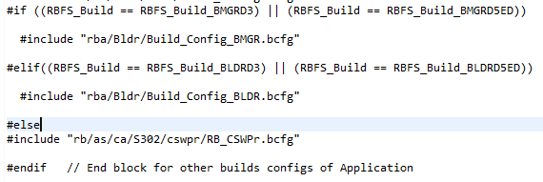

## Cfg_Configurations.xml

Add Boot manager and Bootloader for ECA, ECB and ECC build

**Step** 1:

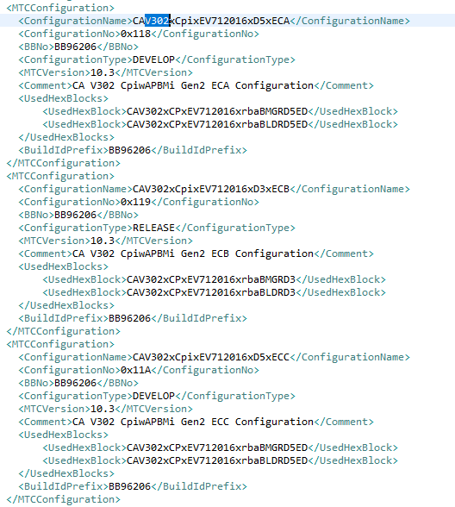

**Step** 2:

Add the new Bootloader and Boot manager variant build configuration

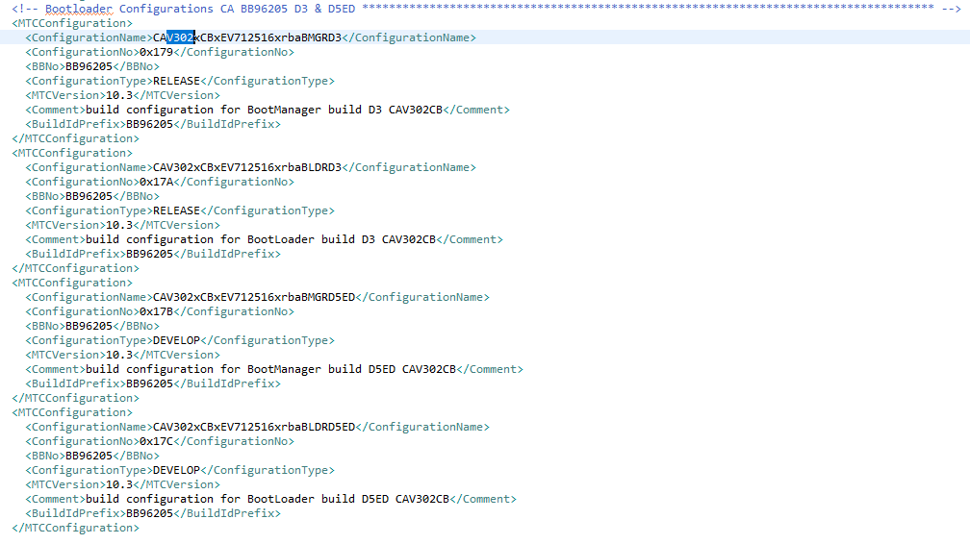

# 2.3 Cfg_MTC_Master_mcfg.xml

**Step1**:

Assign the Build Configuration Function switch for Build Output

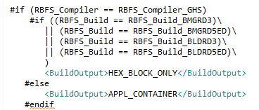

**Step** 2:

Assign the Build Configuration Function switch for GHS_OptimizerOptions

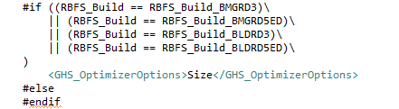

# 2.4 RBCM_CSWPrSettings_F30.h

**Step** 1:

Assign D3 and D5ED Bootloader and Boot manager Build configuration name to Project Layout.

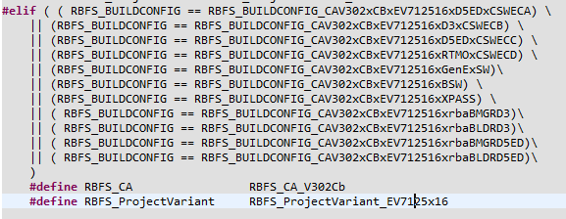

**Step** 2:

Assign D3 and D5ED Bootloader and BootManager Build configurations.

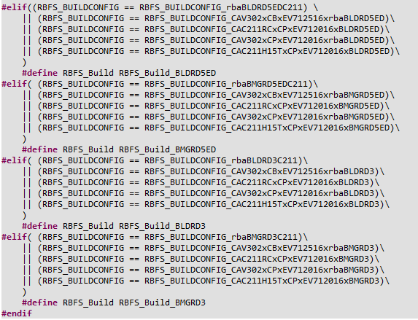

**Step** 3:

Assign D3 and D5ED Bootloader and Bootmanager Build configuration name to PBC supplier (this depends on project feature)

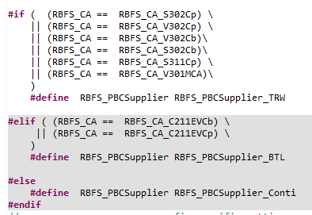

**Step** 4:

Assign D3 and D5ED Bootloader and Bootmanager Build configuration name to BrakeCircuitConfig (this depends on project feature)

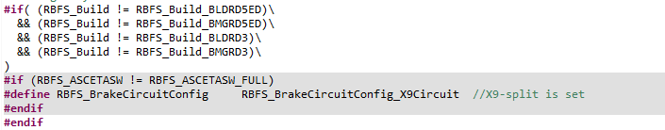

**Step** 5:

Assign D3 and D5ED Bootloader configuration name to enable the bootloader

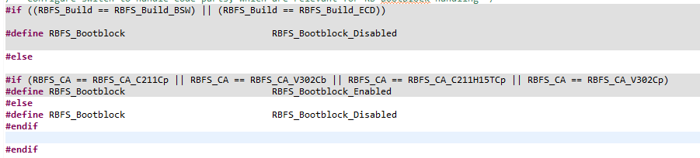

**Step** 6:

Assign D3 and D5ED Bootloader and Bootmanager Build configuration name to HexBlockConfig separately.

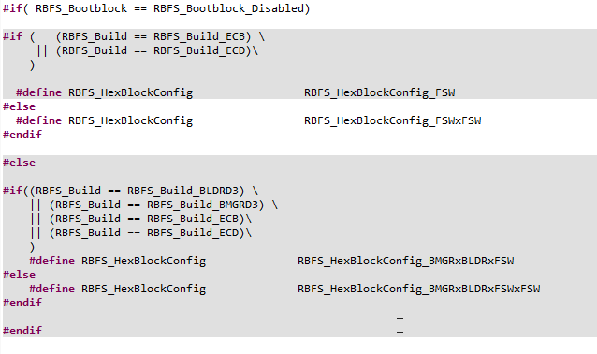**Step** 7:

Assign D3 and D5ED Bootloader and Bootmanager Build configuration name to build the bootloader, boot manager and application build separately.

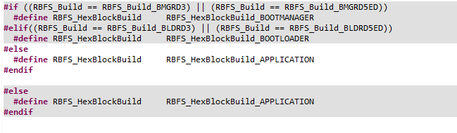

**Step** 8:

Assign RBFS_Bootblock_Enabled to specify the bootmanager size.

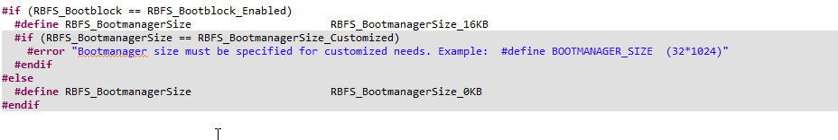**Step** 9:

Assign RBFS_Bootblock_Enabled to specify the boot loader size.

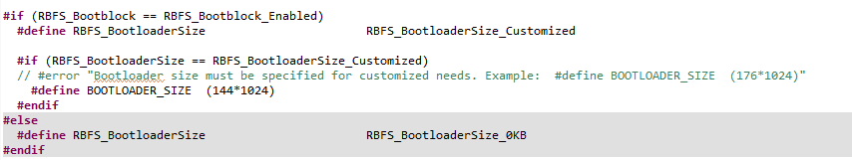

**Step** 10:

Assign D3 and D5ED Bootmanager Build Configuration names to BootblockSysStartupCode



# 2.5 RB_Prj_ConfigSettings.h

Define the project layout macro

#define RBFS_ProjectVariant_EV7125x16 30

# **2.6** RBLCF_Customized_Hexblocks_Allocation_Signature.c

Assign D3 and D5ED (if required) Bootloader Build configuration name to signature part (for root certification).

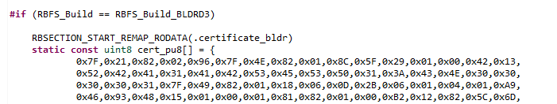

# 2.7 RBCM_HSWPrSettings_F30.cfg

Assign D3 Bootloader and boot manager Build configuration name to select the D3 controller.

